**North Raccoon River Watershed Plan Addendum**

**March 29, 2022**

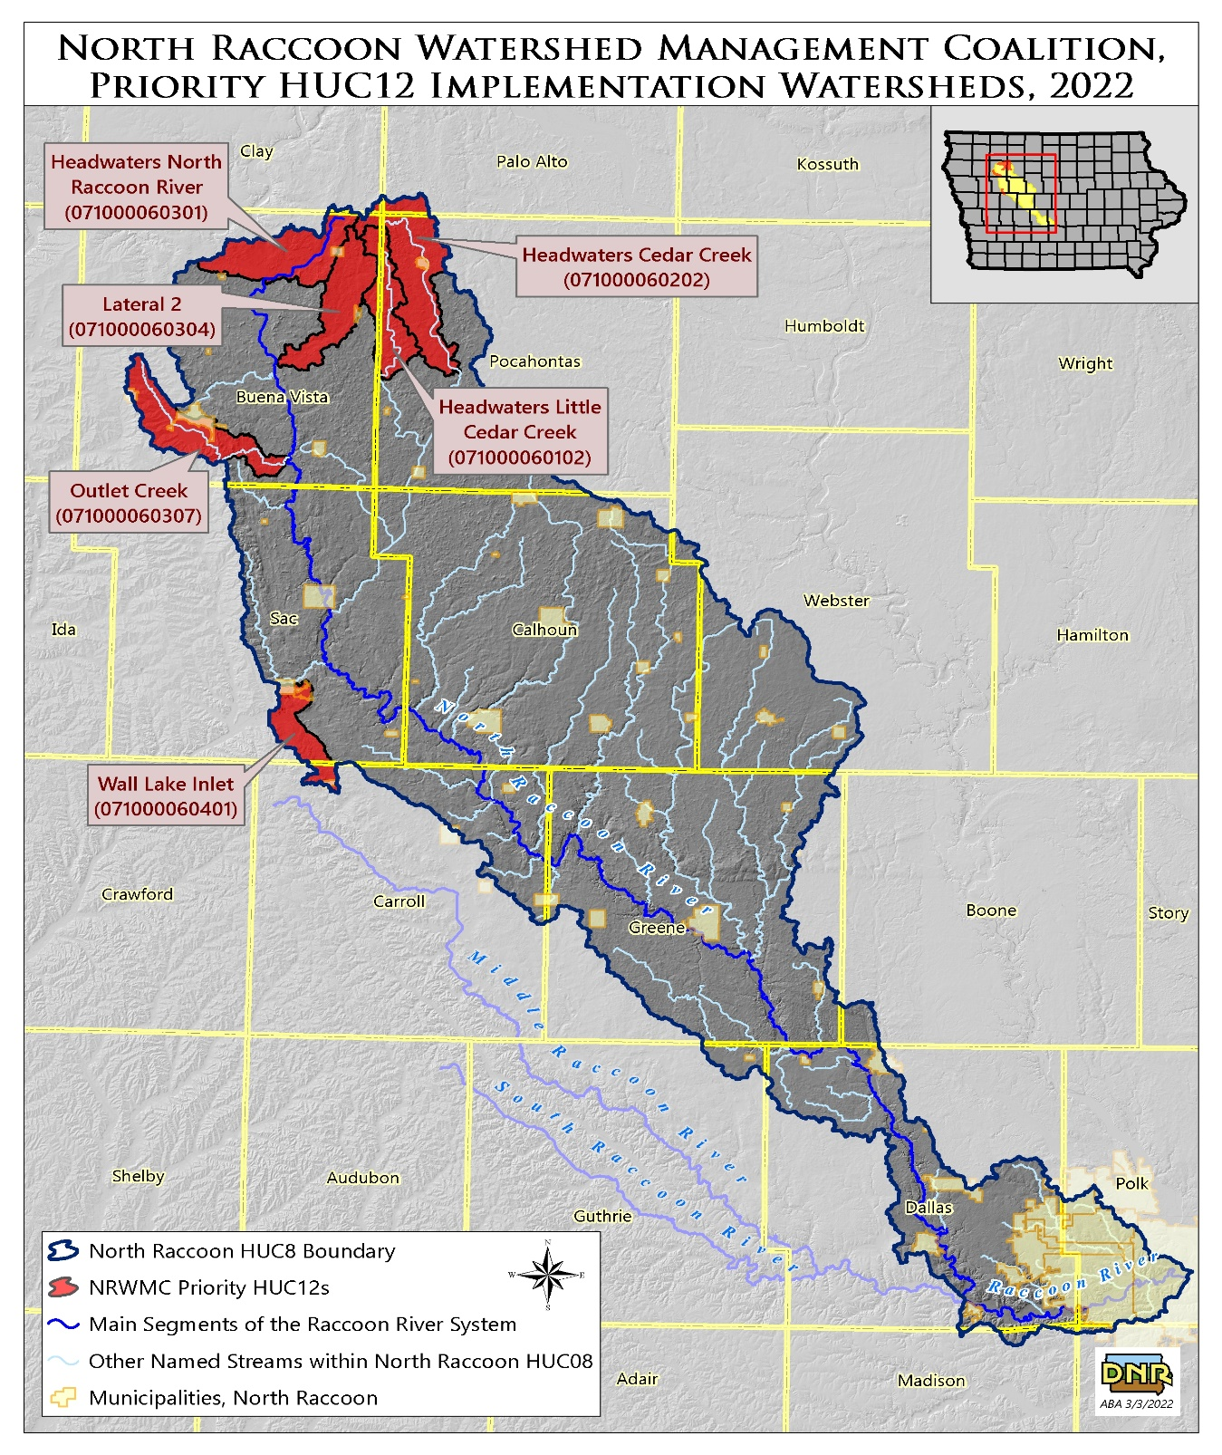The following information is in response to the December 2nd meeting with EPA in regards to the North Raccoon River Alternate Plan Checklist. The North Raccoon Watershed Plan addresses multiple issues in the watershed (nitrate, flooding, E. coli). For the purpose of implementation, the North Raccoon River Watershed Management Coalition will focus on the nitrate impairment at the Raccoon River intake at the City of Des Moines.

Waterbody ID of Impairment: Raccoon River – Des Moines IA 04-RAC-1117

The river segments impaired for nitrate are the two segments of the Raccoon River, located immediately downstream of the confluence of the North Raccoon River and South Raccoon River: IA 04-RAC-116 and IA 04-RAC-117 (Source: ADBnet). Both river segments identify “agriculture” as the source of the impairments. The segments of the North Raccoon River to be addressed by this plan are at the outlets of the subwatersheds identified as having the highest nitrate levels in the North Raccoon River basin. Although the North Raccoon River does not have a drinking water designated use, and is therefore not impaired, it is identified as the primary cause of the nitrate impairments in the two segments of the Raccoon River immediately downstream.

In 2008 a TMDL was completed by Iowa DNR staff for nitrate and E coli. Surface water from the Raccoon River is used by the City of Des Moines for drinking water. Because of the water use for drinking water supply, the Class C water quality standard applies to the Raccoon River at the surface water intake. The applicable water quality standard for nitrate for Class “C” designated use is the United States Environmental Protection Agency (USEPA) maximum contaminant level (MCL) of 10 mg/l. The 2004 305(b) assessment reports that the Class “C” designated use of the Raccoon River at the drinking water intake was impaired due to levels of nitrate that exceed the MCL.

The sources of nitrate can be divided into two major categories, point sources and nonpoint sources. The point sources include municipal, industrial, semi-public, sanitary district stormwater (MS4 permits), and permitted animal feeding operations. There is a total of seventy-seven (77) entities in the Raccoon River watershed with National Pollution Discharge Elimination System (NPDES) permits.

The South Raccoon watershed constitutes 28.9 percent of the area in the Raccoon River above Van Meter, but contributes approximately 20.6 percent of the annual load. In contrast, the Raccoon River above Jefferson comprises 47.1 percent of the land area but nearly 77 percent of the total nitrate export. Similarly, the area above Sac City contributes more nitrate export than the area of the watershed alone would predict. Thus, as suggested by the nitrate concentration data, the North Raccoon River appears to contribute a substantially greater proportion of nitrate loads to the impaired segment at Des Moines (Van Meter to Des Moines) than does the South Raccoon River. These results were confirmed by flow and nitrate concentration modeling using DAFLOW (Diffusion Analogy Surface Water Flow) and WASP (Water Quality Simulation Program) (Appendix A). Modeling suggested that discharge from the North Raccoon River provided 62 percent of the flow at Van Meter, but 79 percent of the nitrate load. Flow from the South Raccoon River provided 38 percent of the flow at Van Meter 21 percent of the nitrate load.

For the purpose of implementation, efforts will be focused within the North Raccoon River Watershed. This is based on the TMDL stating that this area contributes the majority of the Nitrate Loading within the Raccoon River System. The current plan lists the following areas in the North Raccoon River Watershed and will be the focus of implantation for the Section 319 program funding:

**Priority HUC 12s**

The following HUC 12 watersheds are considered the priority watersheds in the North Raccoon watershed plan. These HUC 12s are shown in the North Racoon watershed map (page 1).

Headwaters Cedar Creek - HUC12 071000060202

Headwater North Raccoon River – HUC12 071000060301

Lateral 2 – HUC12 071000060304

Outlet Creek - HUC12071000060307

Headwaters Little Cedar Creek – HUC12 071000060102

Wall Lake Inlet – HUC12 071000060401

**Nitrogen Inputs- Agren Raccoon River Master Plan**

Soil

mineralization 34%

Legume

fixation 16%

Ag fertilizer

23%

Manure

13%

1%

systems

0%

Septic

0%

Turf

grass

Atmospheric

deposition 13%

**Nitrogen Inputs from Non Point Sources**

**Percentage of total,**

**Estimated at Van Meter monitoring station**

Wildlife



The loading/nitrogen inputs across the North Raccoon River watershed are relatively consistent. The six priority watersheds will closely resemble the inputs at the Sac City location.

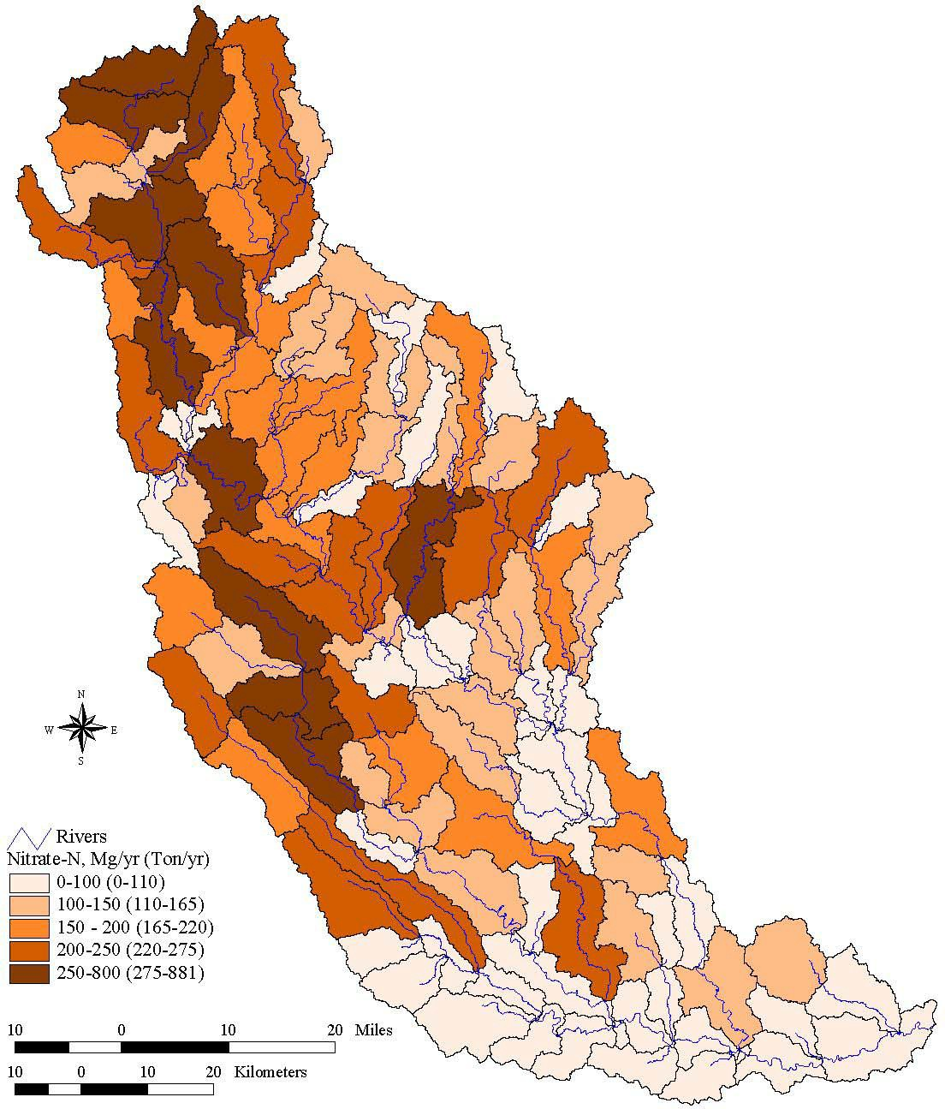

Total annual mass of nitrate exported from subbasins from nonpoint sources (metric tons or Mg per year). Metric tons are converted to tons by multiplying by 1.1.

Figure above (Racoon River TMDL): The six priority HUC12s range from 100 tons/year (Wall Lake Inlet) to 580 tons/year (Lateral 2). Lateral 2 HUC12 contains the highest nitrate export in the Raccoon River Watershed.

**Point Sources**

There is a total of seventy-seven (77) entities in the Raccoon River watershed with National Pollution Discharge Elimination System (NPDES) permits. Most of these facilities are municipal sewage treatment plants, but there are several industrial contributors, animal feeding operations (AFOs) and urban areas covered by Municipal Storm Sewer Systems (MS4s). For this TMDL, load estimates were calculated for WWTPs with Discharge Monitoring Records (DMRs) that discharge measurable quantities of effluent to surface waters. Some animal feeding operations may be considered a point source because facilities larger than 1000 animal units are required to have an NPDES permit. However, by state law, discharge of pollutants from livestock operations is set at zero tons per year (IAC – Chapter 65). Any nitrate discharged from these facilities occurs from either manure application or episodic events such as spills. For open feedlots, facilities larger than 1000 animal units are considered NPDES facilities and their permits require retention and application of manure on cropped fields. Of the smaller open lots, it is required that facilities settle solids before runoff enters a stream. The list of point sources does not include permitted facilities that do not treat an organic waste stream, such as quarry operations. For nitrate, very few wastewater treatment facilities monitor for this constituent in their effluent. Therefore, estimates of the quantities of nitrogen are derived from generic conservative assumptions based on type of treatment, quantity and quality of influent wastewater, and per capita pollutant generation. For nitrate, what little monitoring data is available from WWTPs exists for Total Kjeldahl Nitrogen (TKN) and not nitrate. Hence, all nitrogen point source loads in this TMDL are provided as TKN only. In terms of TKN, 100 percent of the TKN was assumed to convert to nitrate when in fact, some nitrogen is lost from the system as converted plant or soil matter (process known as immobilization) or as nitrogen gas (denitrification). Thus, point source nitrate loads from WWTPs are overestimated.

**Table 3-8**. Summary of WWTP facilities, flow rates, and daily TKN loads in Raccoon River watershed. Basin names: NR-SC = North Raccoon at Sac City; NR-J = North Raccoon at Jefferson; MR-P = Middle Raccoon at Panora; SR-R = South Raccoon at Redfield; RR-VM = Raccoon River at Van Meter; RR-DSM = Raccoon River at Des Moines (Fleur).

**Max**

|  |  |  |  |  |  |  |  |  |  |
| --- | --- | --- | --- | --- | --- | --- | --- | --- | --- |
| **EPA_ID** | **Facility Name** | **Flow Type** | **Type** | **Basin** | **Equivalents** | **(MGD)** | **Type** | **(lb/day)** | **(Mg)** |
| IA0076554 | Rembrandt Enterprises, Inc | Continuous | Domestic | NR-SC | 23952 | 0.0032 | 1 | 232 | 0.1053 |
| IA0033219 | City of Rembrandt | Controlled | City | NR-SC | 407 | 0.5890 | 2 | 117 | 0.0033 |
| IA0046671 | City of Fonda | Controlled | City | NR-SC | 1146 | 1.0240 | 2 | 251 | 0.0129 |
| IA0025950 | City of Laurens | Controlled | City  Semi- | NR-SC | 2383 | 2.2400 | 2 | 359 | 0.0184 |
| IA0065731 | Spectra Health Care Facility STP | Controlled | Public | NR-SC | 71 | 0.0500 | 2 | 15 | 0.0008 |
| IA0064998 | Tyson Fresh Meats Storm Lake | Daily | Industry | NR-SC | 116766 | 2.9490 | 1 | 3260 | 1.4800 |
| IA0032484 | City of Storm Lake | Daily | City | NR-SC | 33874 | 6.2240 | 1 | 1080 | 0.4903 |
| IA0021989 | City of Newell | Daily | City | NR-SC | 1257 | 1.3670 | 1 | 34 | 0.0154 |
| IA0034312 | Albert City | Daily | City | NR-SC | 892 | 1.5000 | 2 | 19 | 0.0086 |
| IA0033090 | Sac City | Daily | City | NR-SC | 4042 | 1.9950 | 3 | 74 | 0.0336 |
| IA0067652 | City of Marathon  **North Raccoon at Sac City** | Daily | City | NR-SC | 461 | 0.4054 | 2 | 8 | 0.0036 |
|  | **Subtotal** |  |  |  |  |  |  |  | **2.1724** |
| IA0057029 | City of Auburn | Controlled | City | NR-J | 455 | 0.3000 | 2 | 128 | 0.0044 |
| IA0056103 | City of Breda | Controlled | City | NR-J | 647 | 1.2000 | 2 | 77 | 0.0066 |
| IA0062162 | City of Lanesboro | Controlled | City | NR-J | 249 | 0.2400 | 2 | 359 | 0.0126 |
| IA0027189 | City of Manson | Controlled | City | NR-J | 1964 | 1.0240 | 2 | 869 | 0.0404 |
| IA0020842 | Lake City  Twin Lakes Sanitary Sewer | Controlled | City  Sanitary | NR-J | 2509 | 2.7700 | 2 | 868 | 0.0294 |
| IA0070114 | District STP | Controlled | District | NR-J | 897 | 0.5880 | 2 | 581 | 0.0197 |
| IA0021300 | City of Jefferson | Daily | City | NR-J | 9281 | 4.5770 | 2 | 125 | 0.0567 |
| IA0041998 | City of Lake View | Daily | City | NR-J | 3221 | 1.0450 | 1 | 35 | 0.0157 |
| IA0026026 | City of Lohrville | Daily | City | NR-J | 659 | 1.0890 | 2 | 12 | 0.0053 |
| IA0020940 | City of Lytton | Daily | City | NR-J | 5305 | 1.6690 | 3 | 582 | 0.2642 |
| IA0033715 | City of Rinard | Daily | City | NR-J | 15 | 0.0550 | 2 | 2 | 0.0009 |
| IA0032409 | City of Scranton | Daily | City | NR-J | 1144 | 1.2200 | 2 | 16 | 0.0074 |
| IA0033138 | Rockwell City  **North Raccoon at Jefferson** | Daily | City | NR-J | 4671 | 10.0000 | 1 | 61 | 0.0278 |
|  | **Subtotal** |  |  |  |  |  |  |  | **2.6634** |
| IA0028983 | City of Coon Rapids | Controlled | City | MR-P | 1542 | 1.6260 | 2 | 232 | 0.0159 |
| IA0056855 | City of Lidderdale  DNR Springbrook State Park- | Controlled | City  Semi- | MR-P | 359 | 0.1350 | 2 | 70 | 0.0024 |
| IA0075281 | Campground Area  DNR Springbrook State Park- | Daily | Public  Semi- | MR-P | 156 | 0.1110 | 2 | 4 | 0.0019 |
| IA0075272 | Education Center | Daily | Public | MR-P | 48 | 0.0114 | 2 | 1 | 0.0006 |
| IA0061468 | City of Bayard | Daily | City | MR-P | 713 | 0.6410 | 2 | 14 | 0.0066 |
| IA0021377 | City of Carroll | Daily | City | MR-P | 20868 | 4.8220 | 1 | 1021 | 0.4635 |
| IA0024571 | City of Glidden  **Middle Raccoon at Panora** | Daily | City | MR-P | 3593 | 1.2000 | 2 | 34 | 0.0154 |
|  | **Subtotal** |  |  |  |  |  |  |  | **0.5063** |
| IA0035181 | City of Dedham | Controlled | City | SR-R | 350 | 0.5000 | 2 | 98 | 0.0033 |
| IA0041866 | City of Guthrie Center | Controlled | City | SR-R | 2222 | 1.3240 | 2 | 1374 | 0.0946 |
| IA0075817 | City of Halbur | Controlled | City | SR-R | 216 | 0.1070 | 2 | 65 | 0.0023 |
| IA0036099 | City of Redfield | Controlled | City  Semi- | SR-R | 1222 | 3.6600 | 2 | 742 | 0.0515 |
| IA0068381 | Diamond Head Lake | Controlled | Public | SR-R | 313 | 0.2500 | 2 | 118 | 0.0082 |
| IA0041874 | City of Bagley | Daily | City | SR-R | 365 | 0.3650 | 2 | 10 | 0.0043 |
| IA0057045 | City of Panora | Daily | City | SR-R | 6174 | 1.2070 | 1 | 122 | 0.0554 |
| IA0041858 | City of Stuart  Rose Acre Farms, Inc. Guthrie | Daily | City | SR-R | 1701 | 3.1320 | 2 | 46 | 0.0210 |
| IA0075361 | Center Egg Farm  **South Raccoon at Redfield** | Daily | Industry | SR-R | 0 | 0.5400 | 1 | 370 | 0.1680 |
|  | **Subtotal** |  |  |  |  |  |  |  | **0.9148** |

**Table 3-8…continued**

|  |  |  |  |  |  |  |  |  |  |
| --- | --- | --- | --- | --- | --- | --- | --- | --- | --- |
|  | | | | | | **Max** |  | | |
| **Flow** | **TKN** |  | **Daily** |
|  |  |  | **Permit** |  | **Population** | **Rate** | **Estimate** | **Daily TKN** | **TKN** |
| **EPA_ID** | **Facility Name** | **Flow Type** | **Type** | **Basin** | **Equivalents** | **(MGD)** | **Type** | **(lb/day)** | **(Mg)** |
|  |  |  | Operation |  |  |  |  |  |  |
| IA0077101 | West Central Cooperative | Continuous | Permit | RR-VM | 377 | 0.8630 | 2 | 3 | 0.0014 |
| IA0057096 | City of Callender | Controlled | City | RR-VM | 407 | 1.4100 | 2 | 297 | 0.0050 |
| IA0031216 | City of Churdan | Controlled | City | RR-VM | 698 | 0.1400 | 2 | 68 | 0.0046 |
| IA0076244 | City of Harcourt | Controlled | City | RR-VM | 365 | 3.4200 | 1 | 9 | 0.0003 |
| IA0023418 | City of Minburn | Controlled | City | RR-VM | 407 | 0.8200 | 2 | 186 | 0.0064 |
| IA0060321 | City of Paton | Controlled | City | RR-VM | 489 | 2.5000 | 2 | 50 | 0.0026 |
| IA0032824 | City of Pomeroy | Controlled | City | RR-VM | 898 | 1.4100 | 2 | 518 | 0.0269 |
| IA0041882 | City of Rippey | Controlled | City | RR-VM | 419 | 0.4000 | 2 | 53 | 0.0028 |
|  |  |  | Semi- |  |  |  |  |  |  |
| IA0076465 | Country View Estates | Controlled | Public | RR-VM | 42 | 0.7050 | 2 | 8 | 0.0003 |
|  |  |  | Semi- |  |  |  |  |  |  |
| IA0076562 | Ortonville Business Park | Controlled | Public | RR-VM | 144 | 0.0140 | 2 | 3 |  |
| IA0041921 | City of Adel | Daily | City | RR-VM | 4820 | 3.1750 | 3 | 133 | 0.0603 |
| IA0056821 | City of Desoto | Daily | City | RR-VM | 1317 | 0.9900 | 2 | 27 | 0.0124 |
| IA0027421 | City of Earlham | Daily | City | RR-VM | 952 | 1.4980 | 1 | 35 | 0.0159 |
| IA0028967 | City of Farnhamville | Daily | City | RR-VM | 467 | 0.2550 | 2 | 12 | 0.0053 |
| IA0020966 | City of Gowrie | Daily | City | RR-VM | 1629 | 1.6250 | 2 | 28 | 0.0127 |
| IA0032379 | City of Perry | Daily | City | RR-VM | 20958 | 8.9060 | 1 | 992 | 0.4504 |
| IA0002089 | Tyson Fresh Meats Perry | Daily | Industry | RR-VM | 60000 | 3.7400 | 3 | 1512 | 0.6864 |
|  | **Raccoon River at Van Meter** |  |  |  |  |  |  |  |  |
|  | **Subtotal** |  |  |  |  |  |  |  | **4.8718** |
|  | Iowa Dot Rest Area #21 & #22 |  | Semi- |  |  |  |  |  |  |
| IA0068888 | I80 Waukee | Controlled | Public | RR-DM | 287 | 0.0600 | 2 | 62 | 0.0032 |
| IA0036021 | City of Van Meter | Controlled | City | RR-DM | 1341 | 1.5750 | 2 | 257 | 0.0132 |
| IA0032794 | City of Waukee | Daily | City | RR-DM | 7868 | 5.4760 | 1 | 138 | 0.0628 |
| IA0035319 | City of Dallas Center | Daily | City | RR-DM | 1904 | 2.2300 | 1 | 43 | 0.0196 |
|  | **Raccoon River at DMWW** |  |  |  |  |  |  |  |  |
|  | **Subtotal** |  |  |  |  |  |  |  | **4.9706** |
|  |  | Event | Storm- |  | | | | | |
| IA0078638 | Storm Lake MS4 | based | water | 4 | | | | | |
|  |  | Event | Storm- |  | | | | | |
| IA0078875 | Waukee MS4 | based | water | 4 | | | | | |
|  |  | Event | Agricul- |  | | | | | |
| IA0079201 | E. R. Peterson & Sons | based | tural | 4 | | | | | |
|  |  | Event | Agricul- |  | | | | | |
| IA0080250 | Wiederin Feedlot | based | tural | 4 | | | | | |
|  |  | Event | Agricul- |  | | | | | |
| IA0077755 | S & S Farms | based | tural | 4 | | | | | |
|  |  | Event | Agricul- |  | | | | | |
| IA0078590 | Van Meter Feedyard | based | tural | 4 | | | | | |
|  |  | Event | Agricul- |  | | | | | |
| IA0080284 | Ray Lenz, Inc. | based | tural | 4 | | | | | |
|  |  | Event | Agricul- |  | | | | | |
| IA0077810 | Wendl Feedlot | based | tural | 4 | | | | | |
|  |  | Event | Agricul- |  | | | | | |
| IA0076295 | Hy.Vac | based | tural | 4 | | | | | |
|  |  | Event | Agricul- |  | | | | | |
| IA0079731 | Corey Agriculture, Inc. | based | tural | 4 | | | | | |
|  |  | Event | Agricul- |  | | | | | |
| IA0080292 | Pudenz, Lynn | based | tural | 4 | | | | | |
|  |  | Event | Storm- |  | | | | | |
| IA0078883 | Grimes MS4 | based | water | 4 | | | | | |
|  |  | Event | Storm- |  | | | | | |
| IA0078867 | Clive MS4 | based | water | 4 | | | | | |
|  |  | Land | Operation |  | | | | | |
| IA0076767 | Vigorena Feeds | Applied | Permit | 4 | | | | | |
|  | Vonnhame Farms Trailer Wash | Land | Operation |  | | | | | |
| IA0080390 | Out | Applied | Permit | 4 | | | | | |
| IA0079782 | City of Truesdale | None | City | 4 | | | | | |

**Differences between HUCs and practices identified for BMP implementation need to be reconciled between Appendix B and Appendix D**

When the consultant (EOR) ran all of the subwatersheds they did it in a way that achieved an overall reduction that met the 48% goal regardless of what each individual subwatershed achieved.  Then, when they ran each of the subwatersheds in the targeted areas we had each of them achieve the 48%.  In other words, they did a batch run on all the watersheds to generate the table for appendix B but did a customized plan for each of the sheds for Appendix D - Pat Conrad (EOR)

**Load Reduction Goals**

Average Annual Load at Raccoon River Upstream of Des Moines = 23,668 tons/year Nitrate

Headwater Cedar Creek Nitrogen Reduction Goal – 95 tons/year

Outlet Creek Nitrogen Reduction Goal – 94 tons/year

Wall Lake Nitrogen Reduction Goal – 40 tons/year

Headwater North Raccoon River – 252 tons/year

Headwater Little Cedar Creek – 72 tons/year

Lateral 2 Nitrogen Reduction Goal - 153 tons/year

Total Nitrate Reduction from priority areas – 706 tons/year Nitrate Reduction

Full implementation of the watershed plans for the six priority areas will result in a deduction of Nitrate Load at Raccoon River upstream of Des Moines of 13.5%. The full plan calls for a 48.1% reduction in nitrate levels.

Critical areas for implementation: Due to the nature of nitrate loss, all agricultural land within the six priority HUC12s will be treated as critical areas.

**Implementation of Plan**

To reach the goals of this plan in relation to nitrate multiple partners and funding sources will need to be utilized. The lead entity for the Section 319 implementation will determined when the Project Implementation Plan (PIP) is developed. Logical partners include:

Iowa DNR - Section 319 program funding/Staff, Source Water Protection Staff

Iowa Department of Agriculture and Land Stewardship (IDALS) – Water Quality Initiative Funding, existing technical staff.

Soil and Water Conservation Districts –Technical support

Natural Resource Conservation Service/Farm Service Agency – Financial support through various cost share programs and housing of project coordinator.

**Staffing Costs**

To implement the plan within the six priority HUC 12s, a project coordinator will be hired to lead implementation efforts, conduct additional data, and collaborate with key partners such as IDALS.

Cost of Project Coordinator - $65,000/year * 20 years = $1,300,000

**Implementation Schedule-**





**Monitoring Plan**

Measuring progress in water quality will be accomplished in two ways:

1. Measure nitrate concentrations/loading at each HUC12 watershed.
2. Utilize existing monitoring networks to monitor changes in water quality over time.

The 20-year implementation plan for the six priority HUC 12s will result in a 13.5% load reduction at the Raccoon River drinking water intake at Des Moines.

A detailed water quality monitoring plan will be developed in the Project Implementation Plan. Multiple agencies will likely be involved in development/implementation of a water monitoring plan (USGS, DNR, Des Moines Water Works, Iowa State University).